Systems Analysis
Major Assignment
CSI1241

Requirements Specification
Version: 0.7.0
Prepared by:
To Be Confirmed
Submitted to:
Priya Rabadia

Tutorial: ES Off-campus

Student no. | Student name:
10371381 | Martin Ponce
10359993 | Francois Pero
10372148 | Adam Johnson
10378977 | Greg Snader

Date of submission:
<Date>

Distribution List

A list of the people that have been issued a copy of this document, in what format, what version and when was it sent.
Who | What (hard/soft copy) | Version | When
Priya Rabadia | Soft copy | 0.5.1 | 29/8/14
Dr. Mike Johnstone
Martin Ponce | Soft copy | 0.1.0 | 20/8/14
Francois Pero | Soft copy | 0.3.0 | 27/8/14
Adam Johnson | Soft copy | 0.3.0 | 27/8/14
Greg Snader | Soft copy | 0.3.0 | 27/8/14

Modification History

Exactly what has been changed in this document since it was created (use active verbs, be specific e.g. “added use case X to use case diagram”), which team member made the change (initials are OK), the new version number that differentiates the changed document from all other versions and the date the change was made. Start at version 0.1, increment by 0.1 for each change.
Who | What | Version | When
Martin Ponce | Initial version. Added functional, non-functional requirements, Assumptions and Out-of-scope. Added glossary terms. | 0.1.0 | 20/8/14
Martin Ponce | Added iOS functional, non-functional requirements, iOS assumptions and iOS out of scope. Added glossary terms. Modified list format from unordered to ordered. Updated TOC. | 0.2.0 | 21/8/14
Martin Ponce | Rewrote functional, non-functional requirements, assumptions and out-of-scope for the development of iOS application. Updated TOC. Updated References. | 0.3.0 | 25/8/14
Francois Pero | Added introduction and assumption 4.1.1 point 4. | 0.4.0 | 27/8/14
Adam Johnson | Added Project Scope, Added Glossary Terms, Modified Introduction, Minor edits to Sections 3 & 4. | 0.5.0 | 29/8/14
Martin Ponce | Defined AccountID as either client or employee unique identifiers. | 0.5.1 | 29/8/14
Martin Ponce | Updated and reformatted functional and non-functional requirements per Priya’s feedback. Removed APP from glossary. | 0.6.0 | 1/9/14
Martin Ponce | Added 5.0 Use Case Diagram (draft) and 5.2 Elaborated Use Case: Search Client Details. Added Client registration as out of scope. | 0.7.0 | 7/9/14

TABLE OF CONTENTS | Page

1.0 INTRODUCTION 7
2.0 GLOSSARY OF TERMS 7
3.0 PROJECT SCOPE 8
3.1 FUNCTIONAL REQUIREMENTS 8
3.1.1 Client must be able to view the services provided by CCC 8
3.1.2 Client must be able to request their sample to be destroyed 8
3.1.3 Client must be able to view the status of their sample 8
3.1.4 Client must be able to securely view and pay invoices via credit card 8
3.1.5 Client Account Manager must only be able to access client details 8
3.1.6 Laboratory Technicians must only be able to access sample data and sample location records 8
3.1.7 Laboratory Managers must be able to access client and sample data records, as well as the internal audit system 8
3.2 NON-FUNCTIONAL REQUIREMENTS 8
3.3 OUT OF SCOPE ITEMS 9
4.0 ASSUMPTIONS 9
4.1 Client assumptions 10
4.1.1 Client registration is assumed to occur outside of the iOS application on CCC’s website 10
4.1.2 Client registration is assumed to create data records and an online account for the client that can be utilised by the iOS application 10
4.1.3 Client registration is assumed to be recorded by CCC’s internal audit system 10
4.1.4 The information and questionnaire provided by the client is reviewed by an employee of CCC before client is accepted 10
4.1.5 It is assumed that rather than emailing clients a link to a secure form to confirm their sample destruction request as outlined in the case study, the secure form will be issued to the customer from within the iOS application where it can be completed 10
4.1.6 Sample data records are assumed to contain fields that indicate the physical and testing status of client samples which can be used by the iOS application 10
4.1.7 It is assumed that there is no GST component in the invoice 10
4.1.8 It is assumed that invoices are only generated and issued electronically 10
4.1.9 It is assumed that clients are warned if their payment is overdue and sample is to be destroyed 10
4.1.10 It is assumed that clients are notified when sample is destroyed for non-payment 10
4.1.11 It is assumed that refunds are processed externally from the proposed iOS application 10
4.1.12 It is assumed that refund of pro-rata annual fee is also provided to clients after requesting their sample to be destroyed and have cancelled their storage plan 10
4.2 Employee assumptions 10
4.2.1 It is assumed that roles are specified within employee user accounts during their creation by the Laboratory Manager 10
4.2.2 It is assumed that employee user accounts are assigned a unique AccountID when created by the Laboratory Manager 11
4.2.3 It is assumed that access to data records within the iOS application by employees is read-only 11
4.3 Application assumptions 11
It is assumed that the iOS application will communicate with CCC’s servers securely using industry standard encryption 11
4.3.1 11
5.0 USE CASE DIAGRAM 12
5.1 ELABORATION OF CLIENT REGISTRATION USE CASE 13
5.1.1 13
5.2 ELABORATION OF <Name> USE CASE 14
5.3 ELABORATION OF <Name> USE CASE 14
5.4 ELABORATION OF <Name> USE CASE 14
5.5 ELABORATION OF <Name> USE CASE 14
6.0 NAVIGATION MAP 14
6.1 App SCREEN#1 - <Name> 14
6.2 App SCREEN#2 - <Name> 14
6.3 App SCREEN#3 - <Name> 14
7.0 DATA DICTIONARIES 14
7.1 ELEMENTARY DATA DICTIONARY 14
7.2 COMPOSITE DATA DICTIONARY 15
8.0 BUSINESS RULES DIAGRAMS 15
8.1 BRD OF <ELABORATED USE CASE 1> 15
8.2 EVENT SPECIFICATION TABLE OF <ELABORATED USE CASE 1> 15
8.3 BRD OF <ELABORATED USE CASE 2> 15
8.4 EVENT SPECIFICATION TABLE OF <ELABORATED USE CASE 2> 16
8.5 BRD OF <ELABORATED USE CASE 3> 16
8.6 EVENT SPECIFICATION TABLE OF <ELABORATED USE CASE 3> 16
8.7 BRD OF <ELABORATED USE CASE 4> 16
8.8 EVENT SPECIFICATION TABLE OF <ELABORATED USE CASE 4> 16
8.9 BRD OF <ELABORATED USE CASE 5> 16
8.10 EVENT SPECIFICATION TABLE OF <ELABORATED USE CASE 5> 16
9.0 REFERENCES 16
10.0 LOGICAL RELATIONAL DATA MODEL 17

INTRODUCTION
One paragraph. Describe the problem and the likely benefits (for the client) of this system.

Cryo Cell Corporation (CCC) wants to develop a mobile application that will enable clients and staff to perform a number of key tasks through their Apple iOS devices. Development of the application offers CCC a number of potential benefits by improving overall customer satisfaction and building the brand. The application will provide better support and improve accessibility for clients. It has the potential to improve sales by exposing clients to additional services provided by CCC. It also has the potential to increase cash flow by improving the turnaround time on invoice payment. The application also offers benefits internally by improving staff efficiency and reducing the administrative load.

GLOSSARY OF TERMS
Anything about the problem domain that your team finds in the case study or refers to in this document that your project manager at McWhirter would not know. Explain the definitions-do not just expand acronyms.

Term | Definition
CCC | Cryo Cell Corporation, the client requesting the system to be built.
AccountID | Unique account number identifier assigned to customer account when successfully registered, or employee when a user account is created by the Laboratory Manager.
SampleID | Unique number assigned to each sample collected from clients.
FacilityID | Unique 3 character identifier for each of CCC’s storage facilities.
FridgeID | Identifier for the storage refrigerator at a CCC storage facility. There are up to 99 fridges at any single CCC storage facility.
CSC | Cryogenic Sample Container, holds up to 16 samples and is used to store client sample for storage. Each CSC has a unique identification number.
CSC Matrix Position | Each CSC can hold up to 16 samples. A location of a particular sample stored in a CSC is identified by the CSC Matrix Position.
CCC Human Resources system | CCC’s existing system which contains a record of all current staff members and their assigned job description.
APPs | Australian Privacy Principles regulate the handling of information by Australian government agencies and some private sector organisations.
SDK | Software Development Kit is a set of software development tools that allow the creation of applications.
Corona | An SDK from Corona Labs Inc. that allows developers to build mobile applications for Apple iOS and Android devices.

PROJECT SCOPE
What the system is supposed to do-one paragraph.
The application will enable existing CCC clients and staff to perform a number of key tasks through their Apple iOS devices. Existing CCC clients will be able to view services, check sample status, request sample destruction, pay invoices and send enquiries, while CCC staff will be able to search for samples, retrieve client details and examine audit records. The application will be developed using the Corona SDK which will allow future versions of the application to support Android devices.

FUNCTIONAL REQUIREMENTS
List these as subheadings e.g. 3.1.1
Any system function that that is mentioned explicitly in the case study.
The proposed iOS application provides functions for both clients and employees. These functions are categorized below.

Client must be able to view the services provided by CCC

Client must be able to request their sample to be destroyed

Client must be able to view the status of their sample

Client must be able to securely view and pay invoices via credit card

    - Client Account Manager must only be able to access client details

Laboratory Technicians must only be able to access sample data and sample location records

Laboratory Managers must be able to access client and sample data records, as well as the internal audit system

  - NON-FUNCTIONAL REQUIREMENTS
Anything that constrains a potential solution that is mentioned explicitly in the case study.

- Client must be able to select between two payment methods
  - Credit card
  - Direct debit, quarterly instalments
- Client must be able to securely view and pay invoices via credit card
- Credit card payment is only accepted via MasterCard or Visa

- iOS application must be developed using Corona SDK

- The iOS application must provide encapsulation for both user types:
  - A client user type must not be able to access employee functions
  - An employee user type must not be able to access client functions
- The iOS application must provide the client with a secure online form to complete to confirm the destruction of their sample, refer to case study for current process
- The iOS application must notify CCC that the confirmation form has been completed to allow for prompt destruction of sample
- The iOS application must interface with CCC’s internal audit system and record the following data when a client or sample data record is viewed by any employee account type:
  - Username/AccountID
  - Date & Timestamp
  - Function (access/edit/create/delete)

  - OUT OF SCOPE ITEMS
What the system is not meant to do.
- Client registration
- Generate printed invoices
- Interfacing with bank/s to generate refunds
- Track shipping
- Access requirements for employees that are not Client Account Managers, Lab Technicians and Lab Managers
- Monitoring storage climates and temperatures
- The development of an iPad version of the application
- The development of the application on the Android platform
- The development of the application on desktop environments ie. Windows/OSX
- Modification of CCC’s existing systems and processes

ASSUMPTIONS
List these as subheadings e.g. 4.1
Assumptions about the case that affect the models in this document. In some places the case may be ambiguous or incorrect. This section allows your team to clarify and make judgements about those ambiguities/errors. The combination of functional requirements and assumptions make up the system scope.

Client assumptions

Client registration is assumed to occur outside of the iOS application on CCC’s website

Client registration is assumed to create data records and an online account for the client that can be utilised by the iOS application

Client registration is assumed to be recorded by CCC’s internal audit system

The information and questionnaire provided by the client is reviewed by an employee of CCC before client is accepted

It is assumed that rather than emailing clients a link to a secure form to confirm their sample destruction request as outlined in the case study, the secure form will be issued to the customer from within the iOS application where it can be completed

Sample data records are assumed to contain fields that indicate the physical and testing status of client samples which can be used by the iOS application

It is assumed that there is no GST component in the invoice

It is assumed that invoices are only generated and issued electronically

It is assumed that clients are warned if their payment is overdue and sample is to be destroyed

It is assumed that clients are notified when sample is destroyed for non-payment

It is assumed that refunds are processed externally from the proposed iOS application

It is assumed that refund of pro-rata annual fee is also provided to clients after requesting their sample to be destroyed and have cancelled their storage plan

Employee assumptions

It is assumed that roles are specified within employee user accounts during their creation by the Laboratory Manager

It is assumed that employee user accounts are assigned a unique AccountID when created by the Laboratory Manager

It is assumed that access to data records within the iOS application by employees is read-only

Application assumptions

    - It is assumed that the iOS application will communicate with CCC’s servers securely using industry standard encryption

USE CASE DIAGRAM
One diagram, one A4 page. Use Microsoft Visio to draw the diagram.

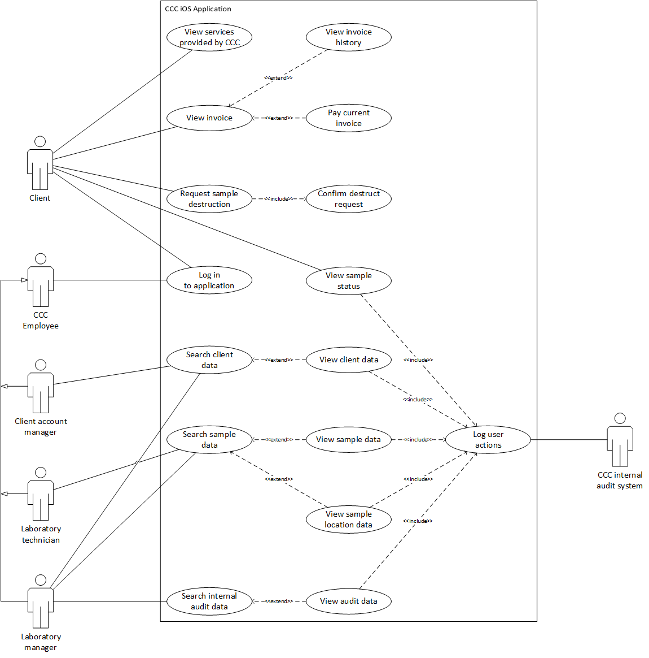

ELABORATION OF CLIENT REGISTRATION USE CASE

Use case: Client Registration
Actor(s): Client, <actor name>…
Purpose: This use case is for registering a potential client with CCC.
Overview: This Use Case begins when the client selects the registration option.
This Use Case does …
This Use Case concludes (or ends) when the system records the information provided by the potential client.
Preconditions: Nil
Postconditions: The system indicates the information was recorded successfully.

Typical Course of Events

Actor Action | System Response
1.Client selects registration option | 2. System request the clients details
3. Client enters details | 4. System displays terms and conditions
5. | 6. Systems offers client two options, "Accept" or "Decline".
7. Clients selects option | 8. IF client selects "Accept" system displays questionnaire, ELSE system directs client to 'Home' page.
9. Client indicate the questionnaire is complete | 10. The system records the information

Alternative Courses

- Step x: <alternative course of action>.
- Step x: <alternative course of action>.
- Step x: <alternative course of action>.

Related Use Cases

Inclusions <name of another use case that this use case includes>
Extensions <the name of a use case for which this use case is the base>

ELABORATION OF SEARCH CLIENT DETAILS USE CASE

Use case: Search Client Details
Actor(s): Client account manager
Purpose: This use case allows the Client account manager to search for vient account details on the iOS application.
Overview: Client account manager enters client search query then system displays search results. Client account manager views client data and the system logs user actions
Preconditions: Client account manager has logged in successfully to the application and wishes to search for client information.
Postconditions: Client account manager locates and views client data, and user activity is logged by CCC internal audit system.

Typical Course of Events

Actor Action | System Response
1. Client account manager enters client search query | 2. System provides search query results
3. Client account manager selects search query result  Extension point: View client data | 4. System displays client data
 | 5. System logs Client account manager username/accountID, timestamp, access type and accessed client accountIDInclude: Log actions
6. System sends logged data to CCC internal audit system
Include: Log user actions

Alternative Courses

- Step 1: Client account manager cancels search, end use case.
- Step 2: Search query provides zero results, system displays message “No results found”, return to step 1, end use case.
- Step 3: Client account manager cancels search, end use case.

Related Use Cases

Inclusions: Log user actions
Extensions: View client data

ELABORATION OF <Name> USE CASE

ELABORATION OF <Name> USE CASE

ELABORATION OF <Name> USE CASE

NAVIGATION MAP
One diagram. Fit onto one A4 page, but you may use the numbered connectors to split Harel Blobs onto another page if needed.

App SCREEN#1 - <Name>
One screen. Fit onto one A4 page. Supply the original diagram separately.

App SCREEN#2 - <Name>
One screen. Fit onto one A4 page. Supply the original diagram separately.

App SCREEN#3 - <Name>
One screen. Fit onto one A4 page. Supply the original diagram separately.

DATA DICTIONARIES

ELEMENTARY DATA DICTIONARY
Data items that fully define artefacts supplied by the client.

Name | Type | Width  (Size) | Format | Constraint

Legend:
A | Alphabetic
N | Numeric
9 | Any digit
X | Any character
D | Date format (dd/mm/yyyy)
$ | Leading spaces
Z | Leading blank or any digit

COMPOSITE DATA DICTIONARY
Definitions created from either elementary items or other composite items. Don’t forget to include the composite definitions of the entities in the logical relational data model here as well as the definitions of the items on the app screens.

BUSINESS RULES DIAGRAMS
Process diagrams of the use case elaborations.

BRD OF <ELABORATED USE CASE 1>

EVENT SPECIFICATION TABLE OF <ELABORATED USE CASE 1>

BRD OF <ELABORATED USE CASE 2>

EVENT SPECIFICATION TABLE OF <ELABORATED USE CASE 2>

BRD OF <ELABORATED USE CASE 3>

EVENT SPECIFICATION TABLE OF <ELABORATED USE CASE 3>

BRD OF <ELABORATED USE CASE 4>

EVENT SPECIFICATION TABLE OF <ELABORATED USE CASE 4>

BRD OF <ELABORATED USE CASE 5>

EVENT SPECIFICATION TABLE OF <ELABORATED USE CASE 5>

REFERENCES
Cryo Cell Case Study.doc
Corona SDK, retrieved on August 20, from http://coronalabs.com/products/corona-sdk/
Australian Privacy Principles, retrieved on August 29, from http://www.oaic.gov.au/privacy/privacy-act/australian-privacy-principles

LOGICAL RELATIONAL DATA MODEL
One diagram, one A4 page. Use Microsoft Visio to draw the diagram.

